

**_______________________________________________________________________________**

Practical-1 Static code analysis using open source tool Flaw-finder

Date: -12/07/2024 Submission Date: - 19/07/2024

**Write-up: -**

* Static code Analysis & Benefits
* Vulnerability
* Flaw-finder

Implement static code analysis using open source tool Flaw-finder for the following:

* Buffer overflow
* String problem
* Race conditions, etc.

Code /Steps:

1. Download Flaw-finder
2. Set up the path where the Flaw-finder
3. Get the test file for the practical
4. Now open the terminal
5. Then check is the flaw-finder is available or not
6. Then run the command flaw-finder command

* Flawfinder test.c

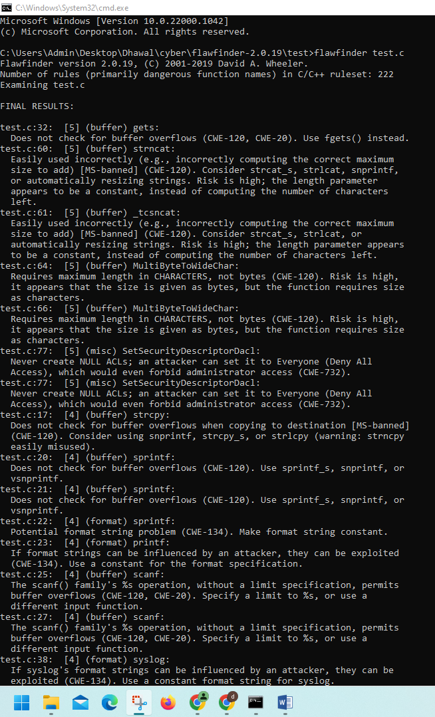Output:

